JAVA PROGRAMMING FINAL PROJECT

Weather Dashboard

A JavaFX desktop application for current weather, forecasts, and saved locations

Pablo Gallardo
COP 2800 - Java Programming
Prof. Mahmudul Haque
Version 1.0 - Mostly Sunny
July 28, 2026

1. Project Description
Weather Dashboard is a native desktop application built with Java and JavaFX. A user can search for a five-digit U.S. ZIP code and view the current temperature, weather condition, humidity, feels-like temperature, wind speed, UV index, sunrise, sunset, and forecast information. The application also lets the user save and manage up to five favorite ZIP codes in a local SQLite database.
The interface uses a dark dashboard layout with a light-mode option, clear loading and offline states, unit controls, built-in help, and an About screen. Weather data comes from Open-Meteo, while Zippopotam.us converts U.S. ZIP codes into locations and coordinates. No API key is required.

2. Problem Statement
Weather information is widely available online, but repeatedly opening a browser and searching for the same locations can be inconvenient. This project provides one focused desktop application where a user can quickly search a ZIP code, see the most useful weather details, and keep frequently viewed locations saved locally.
The project also solves the course requirement of combining a graphical interface with a database. Favorite locations are not temporary interface items; they are stored in SQLite and support Create, Read, Update, and Delete operations.

3. Main Features
- Search by a valid five-digit U.S. ZIP code using the Search button or Enter key.
- Display current conditions, temperature, humidity, wind speed, UV index, feels-like temperature, sunrise, and sunset.
- View a seven-day forecast or switch to an hourly forecast with navigation arrows.
- Switch temperature between Fahrenheit and Celsius and wind speed between mph and kph.
- Save up to five favorite ZIP codes and reload one by selecting it.
- Rename, delete, or reset saved favorites.
- Remember theme, unit, and optional last-viewed-location settings between sessions.
- Show input feedback, loading progress, LIVE/OFFLINE status, and friendly error dialogs.
- Provide Help, Weather Icon, Weather Term, Settings, and About screens.

4. Database and CRUD Operations
SQLite stores favorite locations and application settings in weather-dashboard.db. The database is initialized automatically when the program launches.
Operation | How the application uses it
Create | Save a new favorite ZIP code.
Read | Load saved favorites and settings from SQLite.
Update | Rename a favorite or change a saved preference.
Delete | Remove one favorite or reset the favorites list.
5. Technologies Used
- Java 21 - core application logic and object-oriented programming.
- JavaFX 21, FXML, and CSS - desktop interface, layouts, controls, and visual styling.
- Maven - dependency and build management.
- SQLite and JDBC - local database storage and CRUD operations.
- Jackson and the Java HTTP Client - HTTP requests and JSON processing.
- Open-Meteo - current weather, daily forecast, and hourly forecast data.
- Zippopotam.us - U.S. ZIP code location and coordinate lookup.
- JUnit 5 - automated tests for validation, conversions, favorites, and settings.
- IntelliJ IDEA - development, Maven synchronization, execution, and debugging.

6. Program Organization
The program is separated into classes based on responsibility. Application and controller classes start JavaFX and manage user actions. Database classes create the SQLite connection and perform favorite/settings queries. Model classes hold weather, forecast, and favorite data. The service class contacts the two web services, and utility classes handle ZIP-code validation and unit conversion.
FXML describes the main screen layout, and CSS controls the dark and light themes. This organization keeps interface code, database code, API code, and data objects separate.

7. Input Validation and Exception Handling
- ZIP codes must contain exactly five digits.
- Duplicate favorites are rejected and only five favorites can be stored.
- Invalid input shakes the search field without replacing already loaded valid weather.
- Network and API failures display an OFFLINE state or a user-friendly message.
- Database exceptions are caught so an error does not close the entire application.
- Background weather loading prevents the interface from appearing frozen.

8. Testing
The JUnit suite contains 21 tests. The tests cover valid, invalid, empty, and null ZIP values; Fahrenheit-to-Celsius and mph-to-kph conversions; favorite creation, reading, renaming, deletion, duplicate prevention, and the five-favorite limit; and saving and loading application settings.
Latest recorded result: 21 tests passed and 0 tests failed.

9. Application Screenshots
The following screenshots show the completed application and its major features.
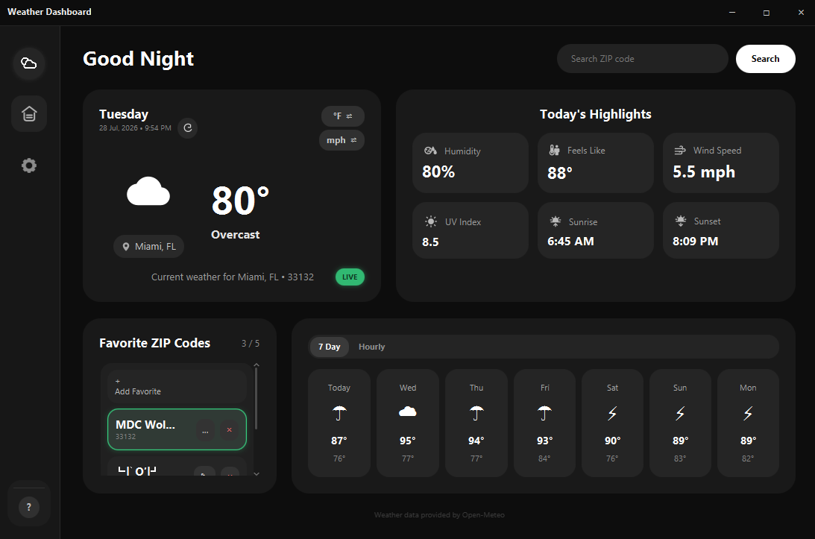

Forecast and Favorite Features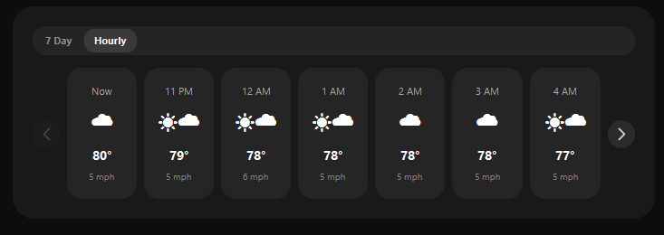
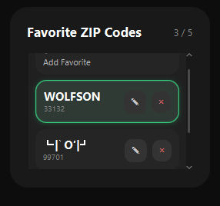

Settings
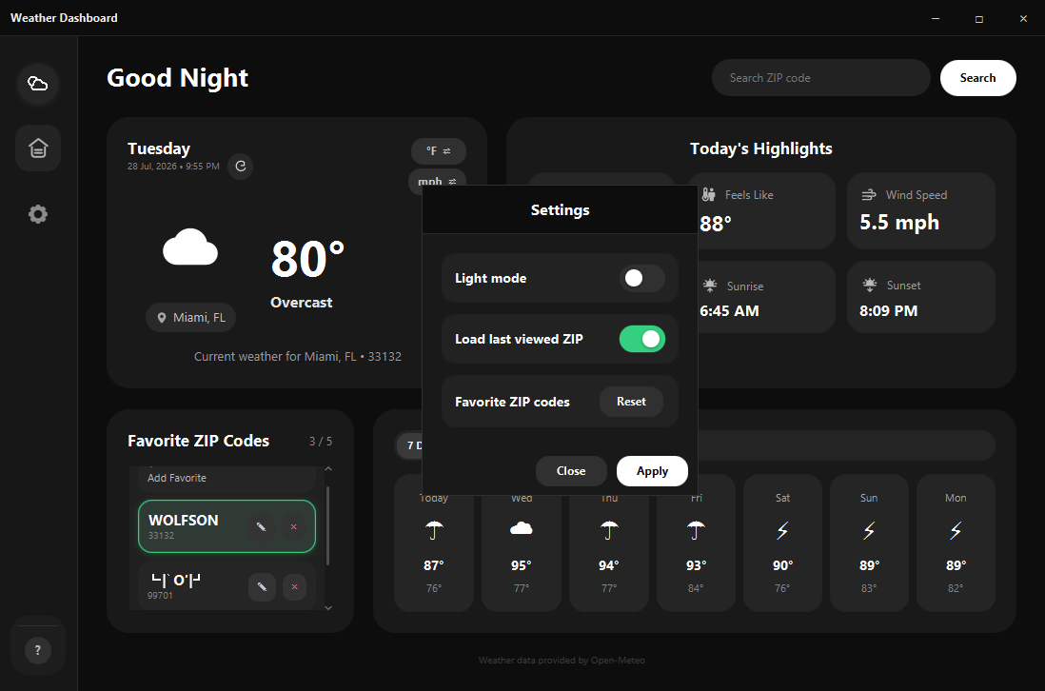

Help and Weather Guide
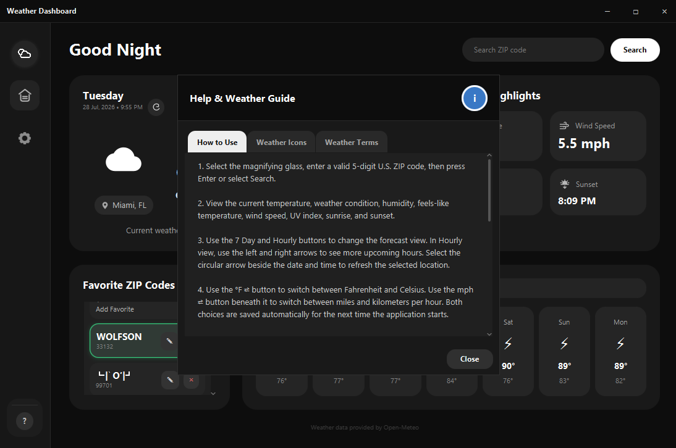
About Screen
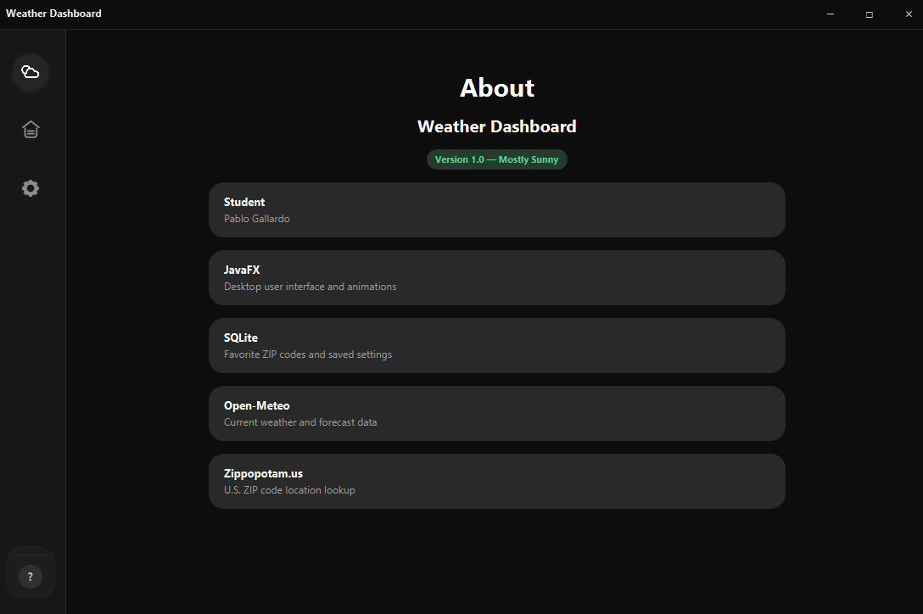
10. Challenges Faced and Solutions

Configuring JavaFX and Maven
The original generated project attempted to compile modules with Java source level 8. I corrected the Maven compiler configuration to use Java 21 and synchronized the project so JavaFX modules and dependencies loaded correctly.

Connecting the Interface to the Controller
FXML controls must use IDs that match the controller fields. A missing connection caused a null-reference error when weather data was displayed. I matched the fx:id values to the controller fields and tested each visible control after the correction.

Keeping the Interface Responsive
Weather requests can take a moment, especially immediately after startup. I used a background task and a loading overlay so the program communicates that work is happening instead of appearing frozen.

Managing Favorites with SQLite
The application needed to prevent duplicate favorites, enforce a maximum of five, support renaming, and preserve data between sessions. I placed these rules in database-access methods and added JUnit tests for the CRUD behavior.

Fitting Information into a Desktop Window
The dashboard contains many weather values without needing the entire window to scroll. I kept the main layout fixed and made only the favorite list scroll when necessary.

11. Future Improvements
- Add severe-weather alerts through a second service such as the National Weather Service.
- Support locations outside the United States instead of limiting searches to U.S. ZIP codes.
- Add historical weather charts and comparisons.
- Package the program as a Windows installer so Java and Maven are not required for normal use.
- Add more integration and JavaFX interface tests.
- Add accessibility options such as larger text and additional contrast choices.

12. How to Compile and Run

Requirements
- JDK 21 or newer
- Maven 3.9 or newer
- Internet connection for live weather data
No weather API key is required.

Run with IntelliJ IDEA
- Clone or download the GitHub repository.
- Open IntelliJ IDEA and select Open.
- Choose the weatherdashboard folder inside the repository.
- Allow IntelliJ to import and synchronize the Maven project.
- Set the Project SDK to JDK 21 or newer.
- Open Launcher.java and run its main method.

Run from a Terminal
Open a terminal in the weatherdashboard folder and run:
mvn clean javafx:run

Run the Tests
From the same folder, run:
mvn test

13. Project Links
GitHub repository: undeadfort/weather-dashboard on GitHub
YouTube demonstration: To be added after the demonstration video is recorded.

14. AI Assistance (Optional)
AI tools were used as a development assistant for planning, troubleshooting, interface ideas, documentation, and test suggestions. I reviewed the code, tested the application, and made the final feature and design decisions.

Examples of Prompts Used
- Help me set up a JavaFX Maven project that runs as a native desktop application.
- Create an SQLite schema and DAO methods for up to five favorite ZIP codes.
- Help diagnose a JavaFX NullPointerException caused by an FXML controller field.
- Add Open-Meteo weather loading without freezing the JavaFX interface.
- Create JUnit tests for ZIP validation, unit conversion, favorites, and saved settings.
- Help organize the README and final project documentation.

15. Data and Design Credits
Weather data: Open-Meteo
ZIP code location data: Zippopotam.us
Interface inspiration: Weather Forecast Dashboard on Figma Community

